3.Write a Pandas program to display the details of jobs in descending sequence on job
title.

Code:
import pandas as pd
jobs = pd.read_csv("jobs.csv")
result = jobs.sort_values(by="job_title", ascending=False)
print(result)
Output:
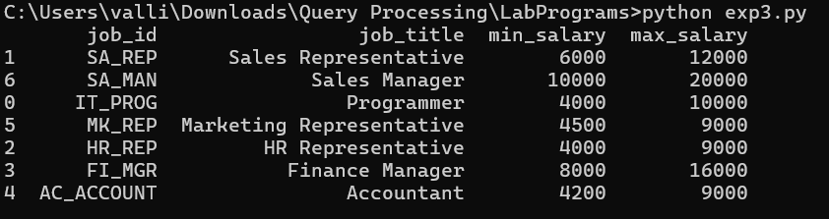

4.Write a Pandas program to create a line plot of the historical stock prices of Alphabet
Inc. between two specific dates.

Code:
import pandas as pd
import matplotlib.pyplot as plt
stock = pd.read_csv("alphabet_stock_data.csv")
stock["Date"] = pd.to_datetime(stock["Date"])
data = stock[(stock["Date"] >= "2016-10-03") &
(stock["Date"] <= "2016-10-07")]
plt.figure(figsize=(8,5))
plt.plot(data["Date"], data["Close"], marker="o")
plt.title("Alphabet Inc. Stock Prices")
plt.xlabel("Date")
plt.ylabel("Closing Price")
plt.grid(True)
plt.show()
Output:
